PHYSICS PROJECT

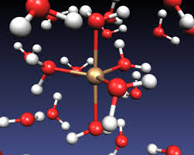 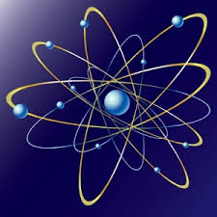

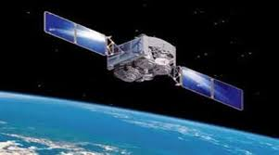 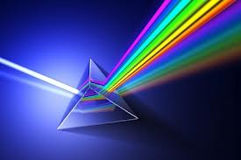

BY – Anish Sachdeva

XII-A

CERTIFICATE

This is to certify that Anish Sachdeva of class XII-A of The Heritage School, Rohini has completed this project solely, sincerely and satisfactorily and carried out genuine investigation about the subject matter and related data collection under my guidance.

TEACHER’S SIGNATURE

ACKNOWLEDGEMENT

* I would take this opportunity to thank from the bottom of my heart many people who supported me unconditionally throughout the preparation of this project.
* I am especially thankful to Mr. Rajiv Chaudhry, my physics teacher for encouraging me to put forward this project.

Anish Sachdeva

INDEX

1. Introduction
2. Experiment –A

* Aim
* Apparatus
* Theory
* Result

1. Experiment –B

* Aim
* Apparatus
* Theory
* Result

1. Application and future scope
2. Bibliography

INTRODUCTION

When a beam of light encounters another transparent medium, a part of light gets reflected back into first medium while the rest enters the other medium.

The direction of propogation of an obliquely incident ray of light that enters the other medium, changes at the interface of the two media. This phenomenon is called REFLECTION OF LIGHT.

According to Snell’s Law,

µ 21 = sin i / sin r

i – angle of incidence

r – angle of refraction

µ 21 – refractive index of second medium w.r.t.

first medium

Due to bending of light at the interface of two media, image formation due to refraction creates an illusion of shifting of object position.

For near normal incident rays, the depth seems to change which can be used to measure refractive index of the medium.

EXPERIMENT – A

AIM-

To find the refractive index of water using a concave mirror.

APPARATUS

* A Concave mirror
* An optical needle
* Iron stand with clamps
* Liquids
* Petri dish

THEORY

When light suffers refraction from a denser to a rarer medium, ray of light bends away from the normal.

When viewed from a rarer medium, the object lying in the denser medium appears to be raised.

If µ is the refractive index of the denser medium, then:

µ = real depth / apparent depth

For near normal incident rays, i is very small, so:

µ = pc / pc /

RESULT

µ of water = 1.329

µ of alcahol= 1.349

EXPERIMENT – B

AIM -

To find the refractive index of liquids using convex lens and plane mirror.

APPARATUS-

* A convex lens
* A plane mirror
* Liquids
* Needle
* Clamp stand
* Metre scale

THEORY

Let a few drops of liquid be put on the mirror. Now place a convex lens over the liquid. A plane convex lens of the liquid is formed between the mirror and lower side of convex mirror and will have the same radius of curvature R as lower surface of convex lens.

Let f and f’ be focal length of convex lens and plane concave lens of liquid and F be focal length of combination.

$$\frac{1}{F}=\frac{1}{f}+\frac{1}{f'}$$

$f$’ = $\frac{Ff}{f-F}$

So by lens maker’s formula:

$\frac{1}{f'}$ = ( µ - 1 ) ( $\frac{1}{R}$- $\frac{1}{∞}$)

$\frac{1}{f^{'}}= \frac{µ-1}{R}$

µ = 1 + $\frac{R}{f'}$

RESULT

µ of water = 1.33

µ of alcahol = 1.38

**APPLICATION AND FUTURE SCOPE**

Measurement of refractive indices of liquids is critical for various industrial, laboratory and medical applications. Due to this inevitability of measurement of refractive indices, this project is of great use and has future scope:

* In sugar industries, it is important to monitor concentration of sugar solution and this can be done by checking its refractive index while preparing.
* It helps in determining the composition of liquid mixtures.
* Refractive index measurement is also a valuable quantity assurance tool for paediatric nutrient base formulations.
* It is also used to determine or measure dissolved substances in complex fluids.
* Concentration of detergent in membrane protein preparation have crucial role in protein stability and function. Refractive index of detergent solution helps in determining the detergent concentration.

BIBLIOGRAPHY

* PHYSICS NCERT (Part –II) for Class XII
* PHYSICS LAB MANUAL, Class XII- ARYA PUBLICATIONS
* CONCEPTS OF PHYSICS, Part – II – H.C.Verma
* [www.wikipedia.org](http://www.wikipedia.org)
* Official site of Indian Academy of Sciences www.ias.ac.in